National College of Ireland

Higher Diploma in Web Technologies

2016/2017

Muhammad Arif

16109830

x16109830@student.ncirl.ie

Online Notes & Tutorials Application

Technical Report



**Table of Contents**

Executive Summary 3

1 Introduction 3

1.1 Background 3

1.2 Aims 3

1.3 Technologies 3

1.4 Structure 3

2 System 3

2.1 Requirements 3

2.1.1 Functional requirements 3

2.1.2 Data requirements 3

2.1.3 User requirements 3

2.1.4 Environmental requirements 3

2.1.5 Usability requirements 3

2.2 Design and Architecture 3

2.3 Implementation 3

2.4 Testing 3

2.5 Graphical User Interface (GUI) Layout 3

2.6 Customer testing 3

2.7 Evaluation 3

3 Conclusions 3

4 Further development or research 3

5 References 3

6 Appendix 3

6.1 Project Proposal 3

6.2 Project Plan 3

6.3 Requirement Specification 3

6.4 Monthly Journal 3

6.5 Other Material Used 3

# Executive Summary

Students always find hard to get content related to their subject because of information overload on the internet.

Online notes app is sloution of students helping each other by sharing their notes and tutorials. Notes and tutorials will layout by rating left by other users. So high rated notes will be on top for easier to find high quality content of the app. Search results will also be shown accordingly.

This web application is for the students by the students who help each other by sharing their valuable tips and notes with others. Any one can share their posts and contents by simply registering in the application. Other registered users can rate others notes from 1 to 5 star. One user can rate one post only once. If one user try to rate one post again this will update their previous rating.

# Introduction

This application is content management system devloped in mainly php. Core functionality of the app is that users can register and share their posts with others. Other registered users can leave review by rating the post from 1 to 5 star rating and can leave comment as review wheter they like the post or not. High rated posts will be shown first on the top to help users to find good quality content easily.

## Background

For most of students like me it is always dilemma to find proper and related infromation about their subject on the internet which is helpful endorsed by other users. Some cases it takes hours and hours to find solution of some problem to work or good quality tutorial which is recommended by others. Today is age of information technlogy and people try to get advice and help from internet whether its food they want to try or its holiday they want to go for. They will go online to check top review websites like tripadvisor and many other to find out which is the best choice recommended by other users who have used the service already.

This application has also adopted the same review idea for student related material. Users can posts notes and tutorials and others can rate if they find it good to recommend others to try this out.

## Aims

The aim of this application is help students and other users to find high quality material easily and quickly to save time. They can try tips and notes recommended by other users who already has tried before. It could be web turorial, code snippet, food recipe, home remedy or anything which they can share with others to try.

## Technologies

PHP is used for server side scripting and javascript, ajax , jQuery, css and html is used for client side script. Bootstrap framework is used for responsive design and main layout of the application with some custom css.

jQuery and Ajax is used to communication and exchage of data between server and client. For example if users submit a form to server ajax request will be sent to server if server send any error back it will be shown on client side by ajax or if task is completed it will be also shown success message to client by ajax.

Mysql database is used to store database information. SQL (structure query language) is used to send data to database or get data from server to display in the application.

PDO (php data object) method is used to connect to and communicate with database server for process of SQL queries and data request.

## Structure

In this report first section is general introduction of project breif description which describe its core fucntionality that what service it provides.

It also give short introduction of background , aim and what technologies have been used to make this project.

In the second section system requirements have been described.

Third section will give conclusion of the project

Fourth section will show if any further development or research is planned after project finished and submitted.

Fifth section is all reference of resources used to complete the project.

Sixth section is final section contains the appendices to this document, like project proposal , requirement spec and any other material used.

# System

## Requirements

### Functional requirements

### Data requirements

### User requirements

In users requirement , user can be either standard user or admin user .Standard user can create posts , leave comments for post or rate a particular post once. User can create , update or delete(curd) only their own posts except for read or view other users posts.

Admin user can create, read or delete any post from application. Admin can also delete other users comment. Admin can block an unblock other users account if any user breach policy of the app or post any inappropriate content in the application.

Admin dashboard will present total number registered users, posts or comments. Admin can also see how many users are online.

### Environmental requirements

### Usability requirements

## Design and Architecture

This web application is mainly developed in PHP and HTML. jQuery ajax is used for exchange data with server and client side. Bootstrap is used for responsive design and main layout of the application. Which enable users to use the application in all devices from large screen to small devices like smart phones.

To interact with with application user required to sign up in order to make posts , leave comment or review any post.

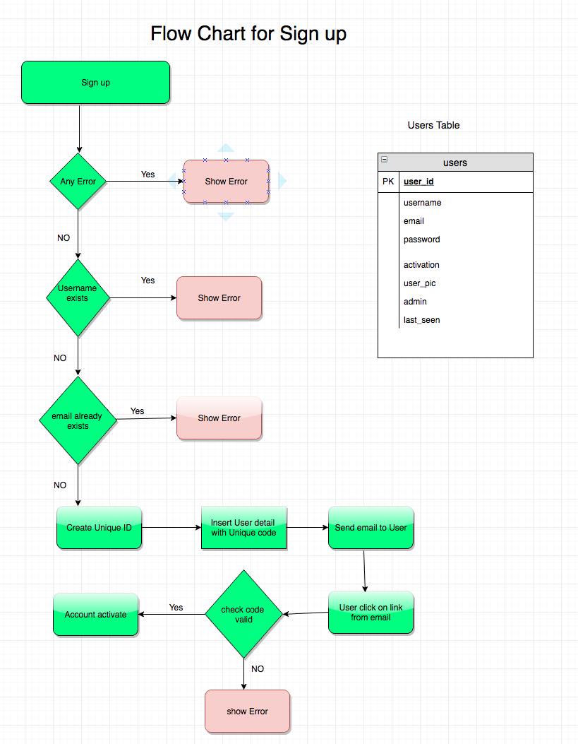

when users signup they will get a link in email with account activation code . user must click on the link to verify and activate account. Once account is verified and activated user is ready to login.

Next process is login screen

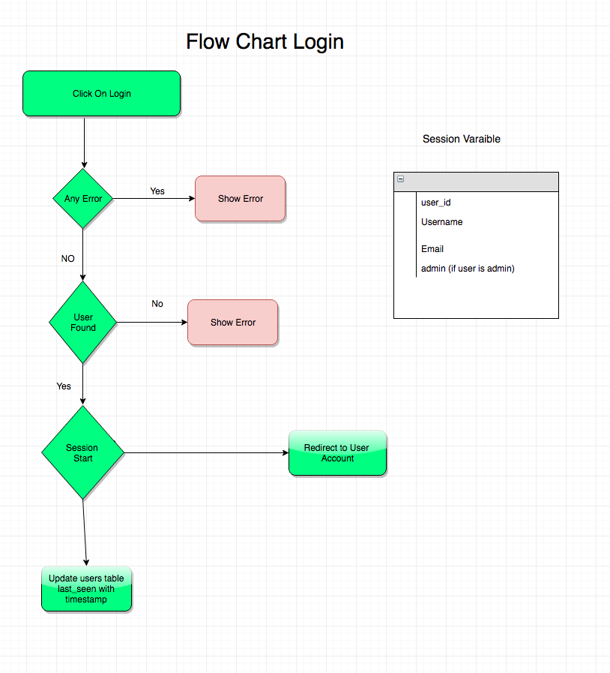

when user logged in successfully it will update users table once again for last_seen column to track users activity of login and see how many users online in admin panel.

Session variables will be activated

If user is standard user following session variable will be created.

$_SESSION[‘user_id’]

$_SESSION[‘username’]

$_SESSION[‘email’]

if user is admin extra session variable will be created

$_SESSION[‘admin’]

which will give admin to access admin panel. Users cant access admin unless they are admin.

All registered Users can create posts if user click on new post .

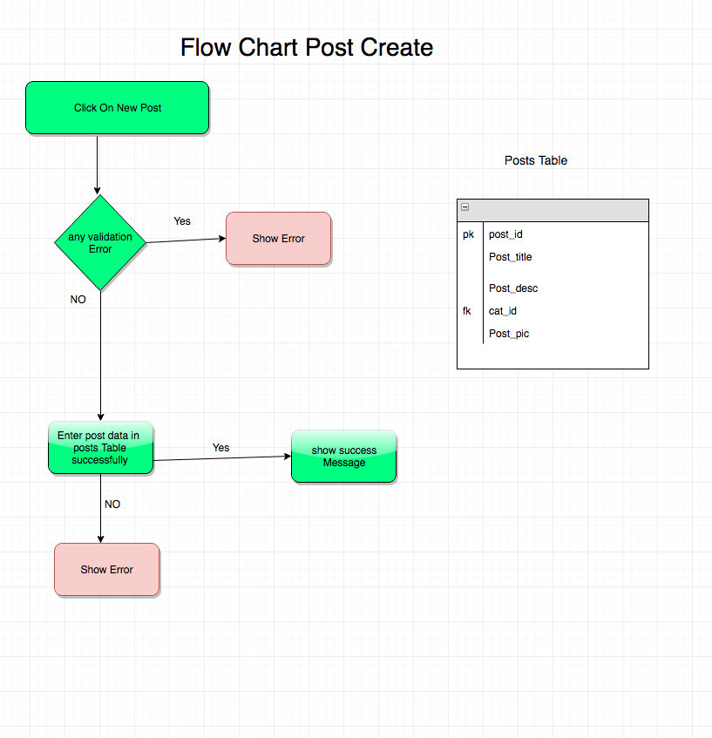

if user want to leave comment on any post, only registered users can see leave a review of the post and comment to any post. User must be logged in to see comment and review section.

If user want to leave comment

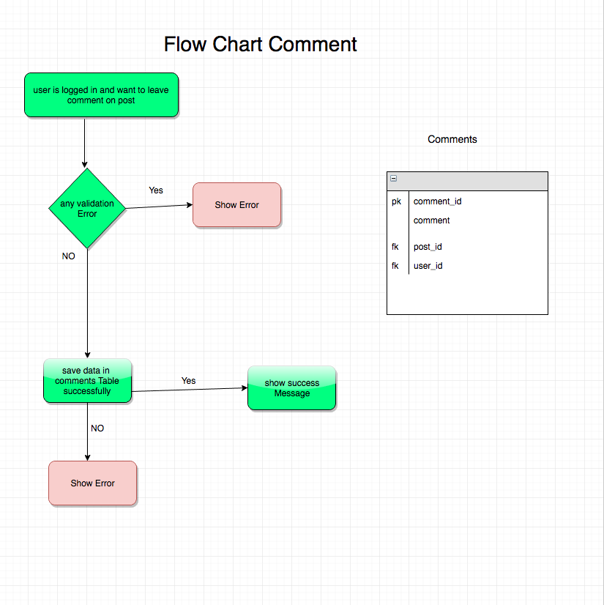

if logged in user want to leave rating for post

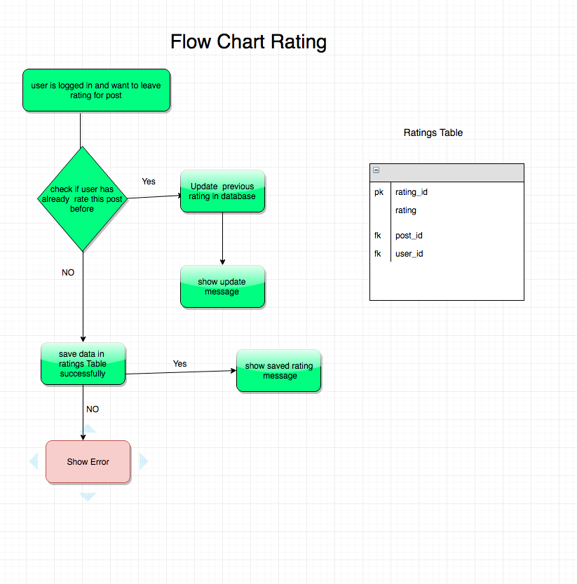

## Database Design

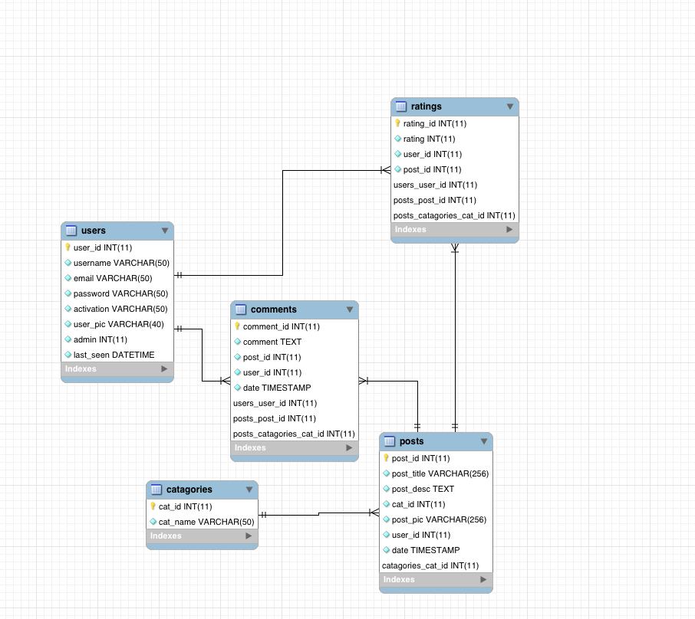

## Implementation

Ajax is used to carry data from client side browser to server and server script process data and send back if any error or success message to client.

$("#signupform").submit(function(event){

event.preventDefault();

// saving form data in variable

var dataform = $(this).serializeArray();

$.ajax({

url: "signup.php",

type: "post",

data: dataform,

success: function(data){

if(data){

// show message or data from php file

$("#signupmessage").html(data);}

},

error: function(){

// show error if aj6x call failed

$("#signupmessage").html("<div class='alert alert-danger'>There was an error occured calling ajax request</div>")

}

});

});

Session variable are used through out application to prevent unathorise access to pages e.g if unregistered user try to access any page via browser they will be redirected to home page as follow:

<?php session_start();

if(!isset($_SESSION['user_id'])){

header("location:index.php");

}

Similarly if user is standard user or unregistered and they try to access admin panel area via browser by typing file name in url. They will also be redirected to home page e.g

?php

session_start();

if(!$_SESSION['admin']){

header("../index.php");

exit;

}

?>

## Testing

1. Html validator test

Few minor errors occurred related to some duplicate id’s and alt attribute was missing from img tag in some lines. Which was fixed later. Otherwise test was error free overall.

<https://validator.w3.org/>

1. CSS test was done

<https://jigsaw.w3.org/css-validator/>

There were some errors showing bootstrap files. Nothing major issue with css files .

## Graphical User Interface (GUI) Layout

Wireframe of home page:

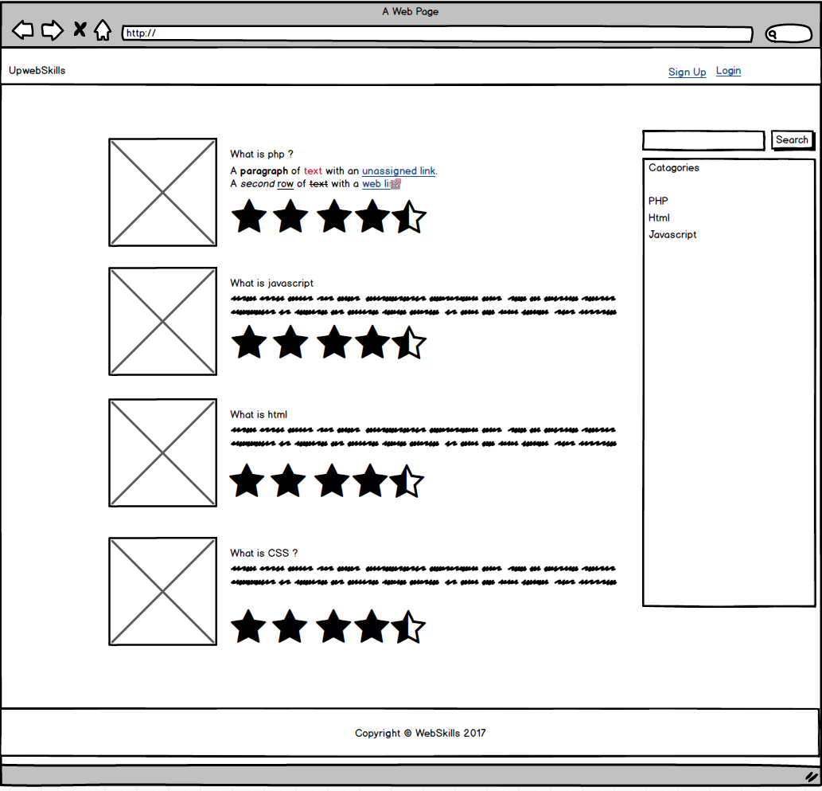

Actual home page screen shot:

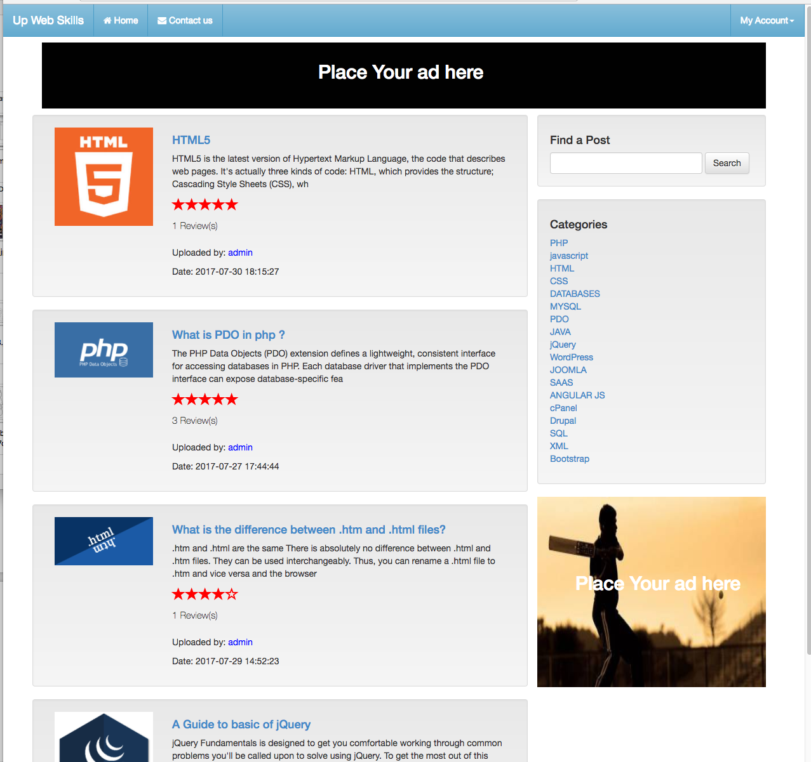

Screen shot of signup modal window:

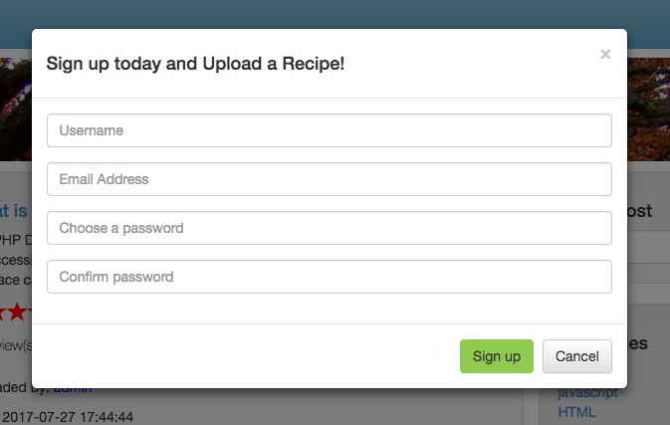

Screen shot of login modal window;

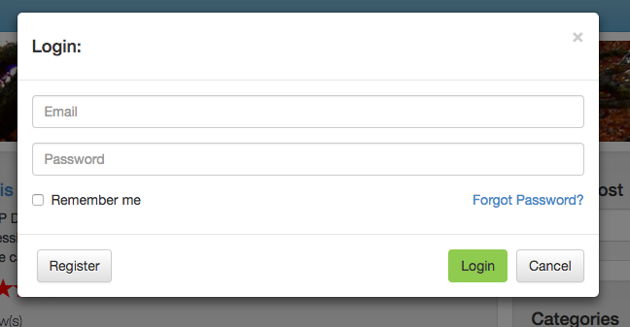

Right menu without login user:

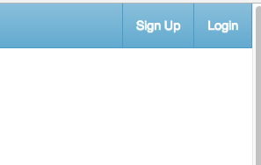

Right navbar with standard login user:

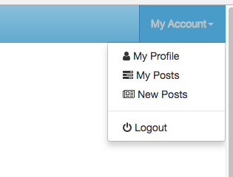

Right navbar with admin user:

Check if user is admin and session variable for admin is created then show navbar as follow:

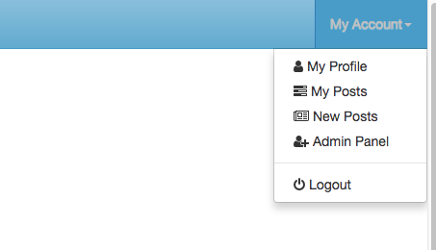

Single post show page without login:



single post with logged in user:

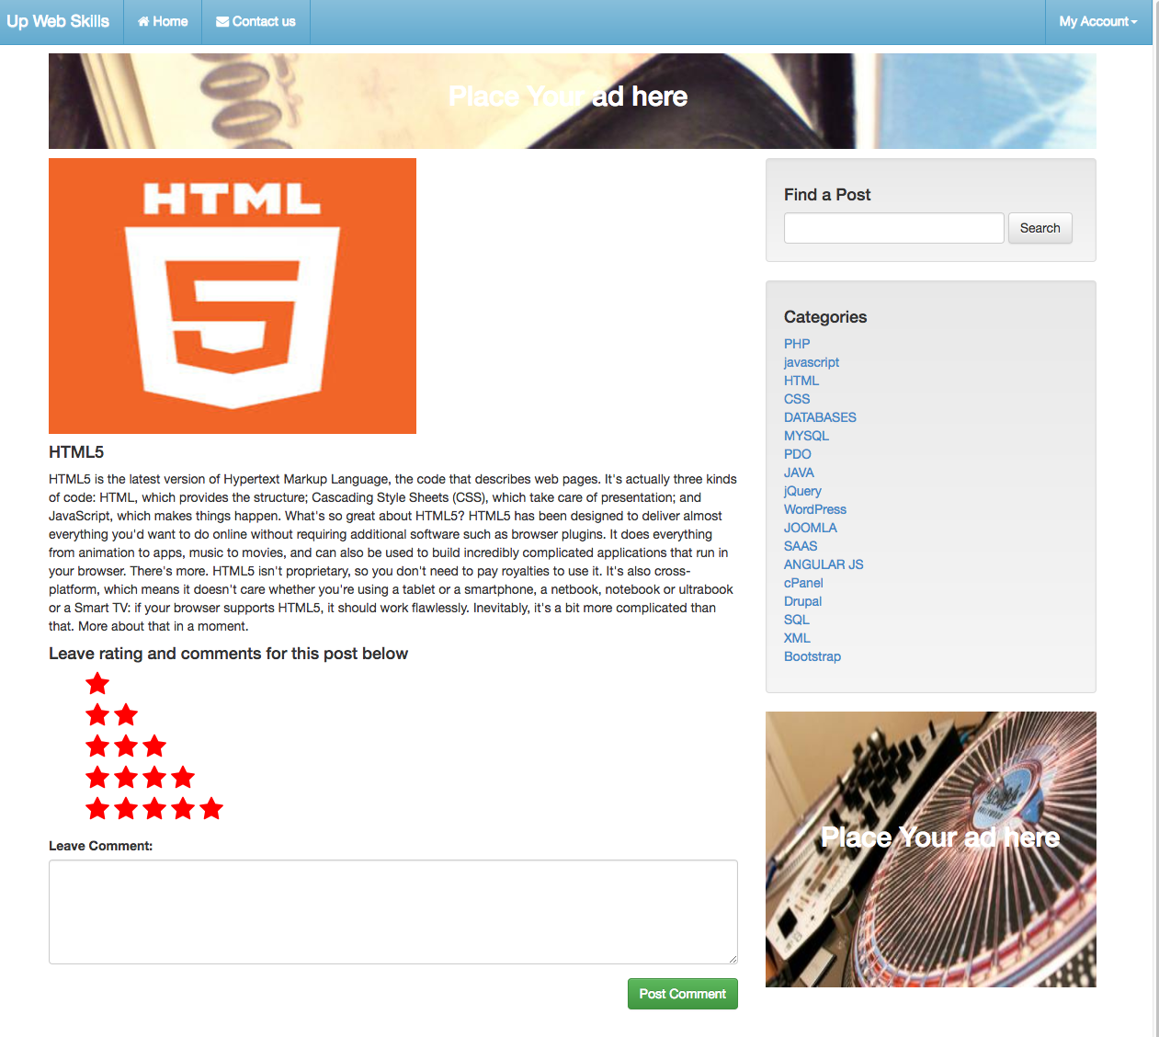

if user is admin then admin can go to admin panel which shows screen like this:

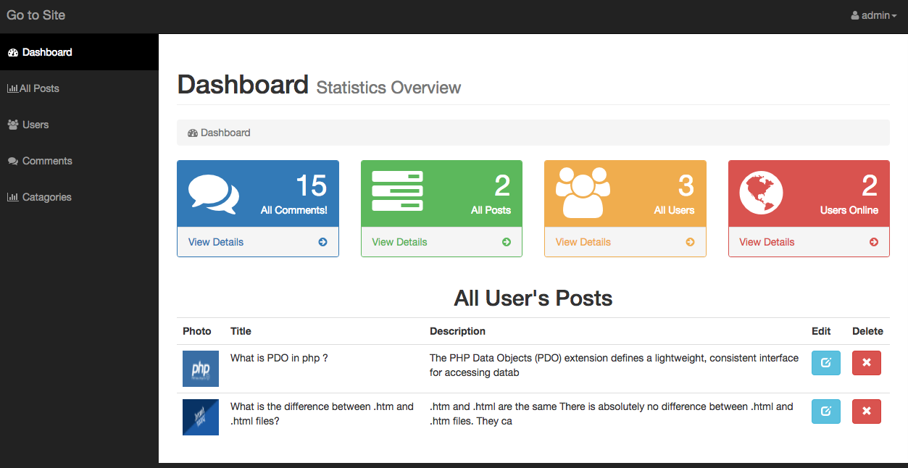

admin can perform crud funcationlity will full acces. Can also block users account.

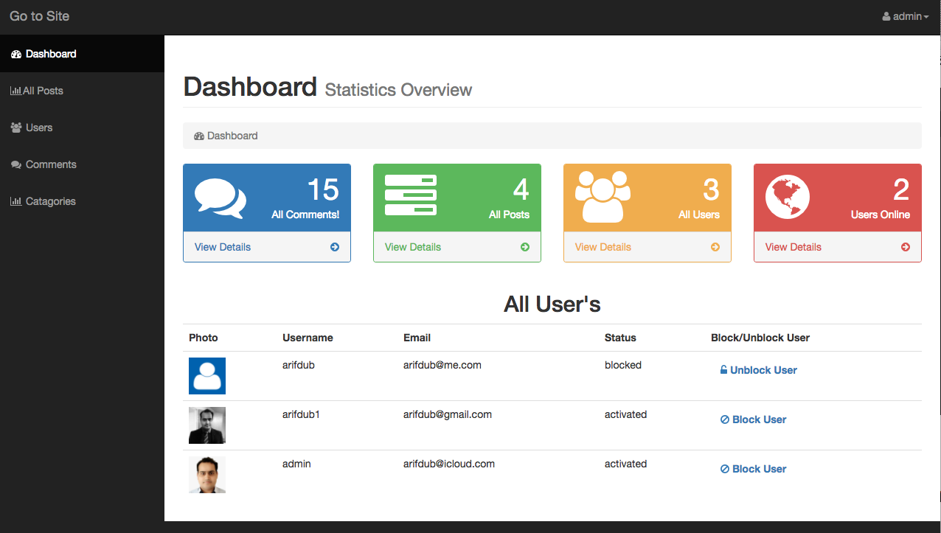

## Customer testing

I have deployed this web application to server for test as real live application. I have asked few people (with no programming knowledge) to test the app and have asked them to register make some test posts. The result shows almost all users could easily navigate through out application with no problem at all.

Feedback I have got from users is satisfactory.

## Evaluation

How was the system evaluated and what are the results? In many cases this will include usage data and user feedback. It may also include performance evaluations, scalability, correctness, etc. depending on the focus of the project.

Quantative results may be reported in tables or figures. Note that tables have their caption above the table and need to be cross referenced in the text (see **Error! Reference source not found.**). In many cases, tables are better to read if you skip the vertical lines.

Table 1: Performance with and without caching

|  |  |  |  |  |  |
| --- | --- | --- | --- | --- | --- |
|  | **Nwithout** | **Nwith** | **Std.-Deviationwith** | **Std.-Deviationwithout** | **p** |
| Records | 100 | 200 | 2.54 | 3.97 | .002 |
| Data (GB) | 100 | 200 | 2.54 | 3.97 | .002 |
| Speed | 100 | 200 | 2.54 | 3.97 | .002 |

Figures have their caption below the figure as shown in **Error! Reference source not found.**. Make sure that if you use colour, the figure is still readable when printed in black & white, e.g., by using additional symbols, patterns, etc.



Figure 1: Learning gain across different experimental groups

# Conclusions

This was my first PHP medium scale project which is almost what I wanted to create. I am very excited and happy with overall output of this project.

With this application we all can help each other by sharing our valuable notes, tips and code snippets. It will be easier to find good quality content easily by checking star ratings.

Usability and graphical interface can still be improved and more functionality can be added in admin panel and users account .

# Further development or research

More categories and sub-categories could be added to expand application for large scale users.

Users interface can be improved.

# References

1- Admin panel front end template:

GitHub. (2017). *BlackrockDigital/startbootstrap-sb-admin*. [online] Available at: https://github.com/BlackrockDigital/startbootstrap-sb-admin [Accessed 22 Jul. 2017].

2- Showing stars for rating of all posts (javacript and css ):

Bootsnipp.com. (2017). *HTML Snippets for Twitter Boostrap framework : Bootsnipp.com*. [online] Available at: https://bootsnipp.com/snippets/featured/functional-star-ratings [Accessed 22 Jul. 2017].

# Appendix

## Project Proposal

Project Proposal

Online Notes Application

Student Name: Muhammad Arif,

Number: x16109830

email address: arifdub@gmail.com

Higher Diploma In Web Technologies

Date : 01/06/2017

# Objectives

This application will help students to make and share their notes, code snippet or study tips with other people so that other students can get benefits from them, One can also make private notes as well as share notes. Private notes can only be seen by login user made by them and hidden from other users.

# Background

There is need to make students discusstion portal where students can help each other in studies and share their tips and cool code snippets with other.

# Technical Approach

## Non Register Users

Non register users can view shared notes and tips from other users. Non register can see the ratings and comments left by other users for notes. Notes will be displayed categories wise and highest rated notes will be display first.

## Register Users

To make notes or leave rating or comment for note or tip, user will be asked to register or login. Login users can either make private notes for themselves or shared notes for anyone to view. Registered users can edit , delete or update only their own notes.

## Registration

For registration, users need valid email address. Email will be verified by sending activation link. So that only email holder can register their email for register in the application.

## Admin panel

There will be admin panel for admin user on backend. Admin can delete, update any note also can remove or ban any user and remove comments. Admin can see all registered users, total no of notes, users online and No. of comments in dashboard.

## More Features and functionality

More features and functionalities could be added depends on the need of the application to improve usability of the app.

# Special resources required

Need any modern browser via handheld device or pc/laptop. No special resources required to write and access notes.

# Technical Details

I will be using Html, CSS, Bootstrap, MySQL Database, PHP, Ajax , JavaScript.

For application layout and design HTML and CSS will be used. Bootstrap will be used for responsive design and style for both desktop and handheld devices like mobile phones and tablets. MYSQL Database will be used to store users login information and Notes. PHP will be used as server side language to talk to database fetch data from server. It will also be used for data validation. Ajax will be used asynchronous communication with database and bring data without refreshing browser. JavaScript will be used for some client side scripting and data validation.

# Evaluation

The application will be developed and tested on local server initially. Then will be uploaded on hosting server for production. So that end users can access it worldwide and can receive a feedback from them. It will be continuously improved according to feedback of the end user.

__Muhammad Arif 01/06/2017_________________

Signature of student and date

## Project Plan

## Requirement Specification

|  |
| --- |
| National College of Ireland |
| Technical Report |
|  |

|  |
| --- |
|  |

Requirements Specification (RS)

Document Control

Revision History

|  |  |  |  |  |  |
| --- | --- | --- | --- | --- | --- |
| **Date** | **Version** | **Scope of Activity** | **Prepared** | **Reviewed** | **Approved** |
| 13/06/2017 | 1 | Create | AB | X | X |
| 17/06/2017 | 2 | Update | CD |  |  |

Distribution List

|  |  |  |
| --- | --- | --- |
| **Name** | **Title** | **Version** |
| Eugene McLaughlin | Lecturer |  |
|  |  |  |
|  |  |  |
|  |  |  |
|  |  |  |

# Introduction

This document give you a better understanding of how the layout of a project is regarding the software requirement needed to implement tasks involved in creating the project from the very beginning to the end product. It’s like a road map to your destination without this the project would run out of ideas in the direct that is needed to finish all application. It’s a clear blueprint to success.

## Purpose

As being a student sometime its very hard to find good material of studies online because of too much information overload on the internet. Its very hard to get proper and specific information related to our subject. The purpose of this web application to share a good studies material found from internet or books and share with other students so they can get benefit from it. In this way one’s hard work could save a lot of time of others.

As this application will be layout and displayed on the base of rating by other users. So it will be easier to find good, high quality material on the top. The Author of the notes will be rated as standard, moderate or expert depends on rating they got from their notes by other users.

## Project Scope

The scope of this project is to develop a web application which allows users to view educational notes, tips and code snippets. Users can register themselves to make their own private or public content in the application. Users can rate others users notes and study tips so that users and students can get benefit from high rated content.

This application could be beneficial for almost everybody, because tips for anything can be shared. From household DIY tips to cooking recipes and study notes.

Other registered users can view, comment, rate and share on social media any note or tip from web application. Owner of the content can create, update and delete their own content only.

# User Requirements Definition

The user requirements are the step by step approach to understanding what is require within the application, just as if you were using an app on your phone there are different sections within the application, whether it’s going from the sign in screen to the home screen and going to different screens within the application. We must plan the requirements to enter into the responsive web application were we make it easy to use and friendly for all ages giving of any but also meets their needs.

# Requirements Specification

This gives you a detailed specification of all the different components within each use case. In doing this it gives the user the better understanding of how each component works within the layout of the screen. This helps both the developer and consumers to understand how it works in the design element of each requirement specification within the use case. By the way of testing the components before entering the market it is tested for errors.

## Functional requirements

The functional requirements is a guide to how your application work in regards to the software system whether certain functionality within the system works for example sign in or going to different screens went you click a button or enter some information into the screen and submit it, all these different aspects must be fully functional before it goes live. The registration and the sign in are the most important function requires for the application otherwise the user can’t avail of the application and becomes useless.

### Use Case Diagram

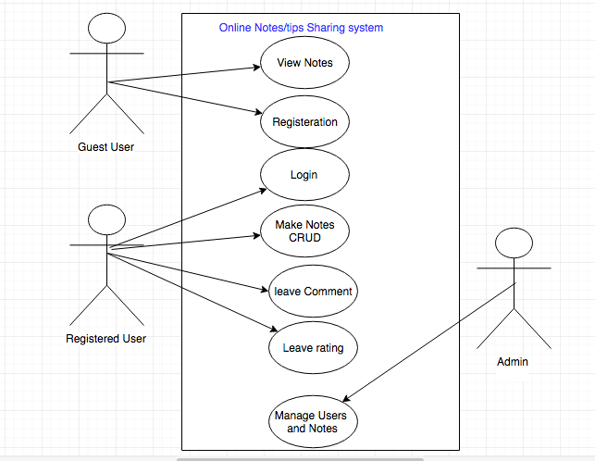

Non-register or guest users can use application to just view public notes and tips. They cannot interact with application at all except to register.

To interact with system users must need to register and login

### Requirement 1: “User Login”

#### Description & Priority

The User will need to have an account to access the website so they can use it. They must enter their own personal unique identifier by the way of a username and password to account their own account. If they are a first time user they must create an account by the way of filling out an online registration form and once this is done. They are asked to sign in like all existing users.

#### Use Case

#### ../../../../../Desktop/Screen%20Shot%202017-06-17%20at%2022

**Scope**

The scope of this use case is to allow the user to enter their account on the application

**Description**

This use case describes the correct procedure of how enter their own account by the way of set of instructions to be followed and if the procedure is incorrect. The user has option to reset their details to gain access to the account.

**Flow Description**

**Precondition**

The system is idle

**Activation**

This use case starts when a user clicks on the website

**Main flow**

1. The User enters the URL in to the browser.
2. The User click the enter button.
3. The System returns with the Home Screen of the application**.<A1>**
4. The User then clicks on the Sign in button.
5. The System returns the Sign in Screen.
6. The User must enter the sign in details.
7. The User clicks the Submit Button.
8. The System verifies the details**.<E1,E2>**
9. The System allows access to the user account of the application.

**Alternate flow**

A1: **The User Register a new Account**

1. The new User clicks on the registration button of their choice.
2. The system returns the registration screen.
3. The User must enter personal details on the online form.
4. The User enters personal details.
5. The User then clicks the submit button.
6. The System stores the information.
7. Users will get link in email to verify account and users must verify it before login.
8. The System returns a message for the user to sign in.
9. The User clicks on to the Sign in screen.
10. The User enters the personal details.
11. The system response with access to the users account.

**Exceptional flow**

E1: **Incorrect User Sign in Details**

1. The user enter in the email address and password
2. The system returns with incorrect details
3. The system asks the user to re-enter password
4. The system gives you 3 attempts to re-enter password
5. The system allow access if correct password gain entry.
6. The system will locks out if unsuccessful **<E2>**

E2: **Reset User Sign in Details**

1. The user must click the reset password button on the log-in screen.
2. The system asks for an email address.
3. The user enters email address.
4. The user clicks the submit button.
5. The system sends an email with a link to reset password.
6. The user clicks on the web page link.
7. The system shows the screen to reset the password.
8. The user enters new password.
9. The user clicks the submit button.
10. The system returns the user to the log-in of the main flow.

**Termination**

The application terminates when the user signs out.

**Post condition**

The system goes into a wait state.

### Performance/Response time requirement

The latest technology will be used to give excellent performance and response times with the speed of high quality broadband speeds available

### Availability requirement

The availability depends on the access of a personal computer, laptop, tablet or smart phone but also the availability of the internet system working in your area at the time of trying to access the application

### Recover requirement

The system will have a backup system that if anything happen to the system it automatic reboot to that system, so that the user cannot lose an important information if the system crashes.

### Security requirement

The system will use the latest security software available regarding identification and authentication system the create the user to registration by using personal identification and a unique password

### Reliability requirement

The system reliability will depend on the latest broadband speeds available at the time the system is being used.

### Maintainability requirement

The system will be kept updated with the latest software system updates by the system administrator regarding the latest technology on the market at the time.

### Portability requirement

The requirement is to make this a responsive web application so that this application can be used anywhere and at any time with a laptop, tablet and smartphone.

# System Evolution

This web application will be used globally for all types of users like students, home users, chefs, developers, designers. It will provide tips and tricks for every type of person. This application can be extended for adding more and more categories in it. So that majority of people can share their ideas, tips and code snippets to benefits others.

## Monthly Journal

## Other Material Used

Any other reference material used in the project for example evaluation surveys etc.

CD containing code should be glued to the technical report.